**Inbound Payroll Integration Data Guidelines** 

**The following are important guidelines to help reduce errors.**

**File Name:**

# Dos

Please use the following format to name the payroll files:

<StandardPlanID>_<PayrollVendorID>_<PayrollFile>_<YYYYMMDDHHMM>.csv

* The StandardPlanID is the client’s six-digit contract/plan number at The Standard. This value will be provided by The Standard.
* PayrollVendorID is a unique identifier specific to each payroll provider and will be provided by The Standard.
* PayrollFile is a user-defined section available for customization for client or vendor tracking. o If you have no desired customizations, please just include the text “PayrollFile.”
  + For plans that have multiple payroll files per pay period, we suggest using the “PayrollFile” text to differentiate the files. This will allow our mutual client to identify the correct file for funding their payroll.
  + For example if Plan A has two divisions the files could be named:
    - <StandardPlanID>_< PayrollVendorID>_1234_PayrollFile_<YYYYMMDDHHMM>.csv
    - <StandardPlanID>_< PayrollVendorID>_5678_PayrollFile_<YYYYMMDDHHMM>.csv
  + Please include dates in your file name. The formatting of the date and the specific time of the file are up to your discretion.

**E.g.,** 123456_ProviderX_PayrollFile_09142018.csv

123456_ProviderX_1234_PayrollFile_201809140044.csv

* The file extension should be ‘.csv’ and must be in lower case.

# Don’ts

* **File name extension should not be in upper case.** Files with.csv extensions should be in lower case. With upper case file extension, files will not be loaded successfully**.** E.g.,123456_RPlanPayroll_201809140044.csv

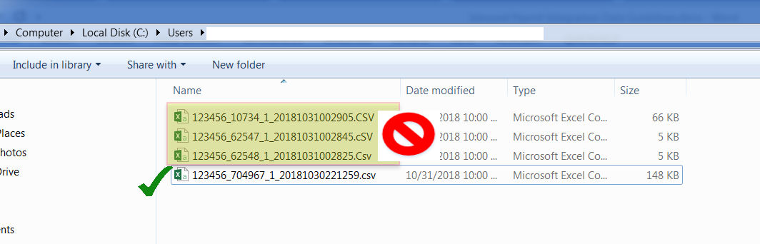

* Please do not include special characters in file name.

**Inbound File Content:**

# Dos

* **Column Headers are required.** The first row of the file is the header row and it can have any character without quotes or special symbols**.**

* **Pay Date, Payroll Begin Date and Payroll End Date are required.** The second row of the file provides payroll date information to The Standard. 
  + These three columns must always be the last three columns following other participant information.o Date format should always be in MM/DD/YYYY format even if other date formats are used elsewhere within this file.o Although these dates can be included in all rows, they are only mandatory for the second row.

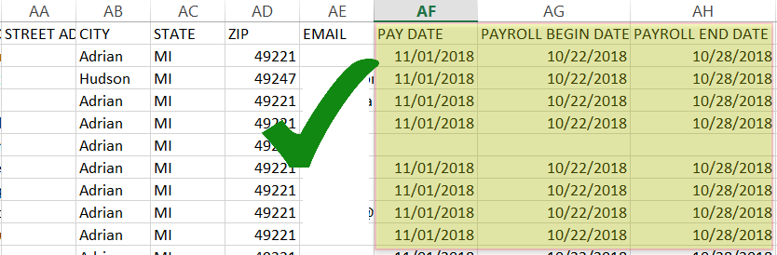

* + Also note that payroll dates must always be the same for all participants on the file. The Standard’s internal application will only consider the dates that are in the first row following the header row.



**Note:** If plan sponsors want to have different date, they should upload multiple payroll files by grouping participants having the same payroll dates.

**Participant data rows:** Participant data row will begin from the second row of the payroll file.

* **SSN:** The first column must always be SSN. Leading zeros should be included.
* **Date format:** The date format defined in the template should be followed. For example, if the date of birth in template is MMxDDxYYYY while payroll file has DDxMMxYYYY format, then error message will be displayed in The Standard’s internal application. Check the “automated inbound” template provided by the payroll integration team about the date format which needs to be followed.

**Note:** If a .csv file is opened in excel and saved, date columns having dates starting with 0 will be truncated, which will cause error messages during validation.

* **Date format for Pay Date, Payroll Begin Date and Payroll End Date columns:** The last three columns should always be MMxDDxYYYY format. Changing the format would cause the file not to get loaded successfully.

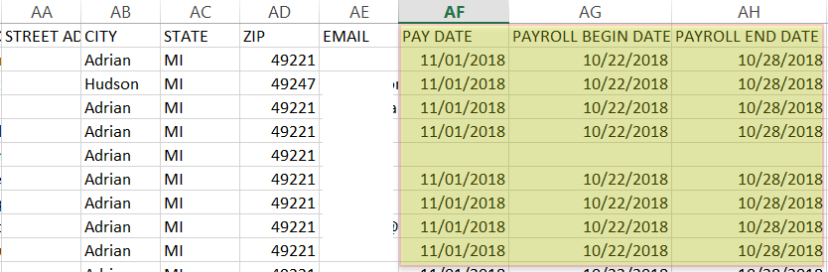

* **Name:** The **F**irst Name and Last Name column should be separated into two columns.

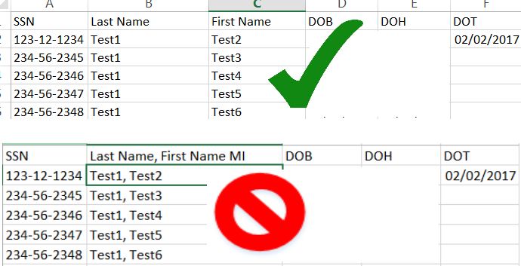

* **ZIP Code:** Leading zeros should be included. If a four-digit extension is used, use “-“ to separate the extension.
* **Deferral amount:** If the plan allows participants to defer percentage or flat dollar amounts, the file should only contain one option (not both) for any given source.
* **Payroll file should match the template:** If the columns in the payroll file don’t match with the template file columns, processing would cause errors in the system. The payroll integration team can be reached to ensure the generated payroll file matches with the template.
* **Email ID field:** You can have a maximum of 40 characters for the email Id and should follow the approach below:
  + - First character can only be of valid character set (A-Z) or number. o Email ID before “@” can have any these special characters: “$”, ”!”, ”_” and dot operator only and not others.
    - After the “@” operator, the email ID can have the following special characters “$”,”!”,”_” and dot operator only; other special characters are not allowed.
* **For hours and compensation fields, Per Pay Period is preferred.** 
  1. If you maintain actual hours worked for each employee, report that number on your employee data files.
  2. If you do not track actual hours worked, you can use an equivalent. The equivalent must be identified in your plan document. For example, if your plan document provides an equivalent of 45 hours per week, each employee that worked at any time during that week would be credited with 45 hours in place of actual hours.

**Employees to be Included:**

* Include information for **all employees** who are employed at any time during the payroll period.
* If the plan document excludes any groups of employees from the plan, you can provide census information for them using one of the following two methods:
  1. Include the excluded employees in your payroll file and code them with a “1” in the Excluded Employees field as shown in the Payroll Data File Format that follows this page, if applicable.
  2. Provide the information to us at the end of the plan year and exclude them from your payroll data file.
* Include new employees in the data file immediately after their dates of hire.

* Terminated employees should remain on the data file through the reporting of their last contribution and termination date. The data file following their last contribution must include the Date of Termination, and a zero (0) must be placed in the Contribution Rate Pre-Tax column. A zero (0) must also be placed in the Contribution Rate Roth column, if applicable. Once final information has been submitted, please remove them from the file.

* When an employee has been rehired, enter the most recent Date of Hire as the hire date.

# Don’ts

* **Gender having 0 as value:** If a plan sponsor does not want to identify the gender for a participant that respective record can be left blank. If 0 is entered, the system would generate an error message while validating. It should be either blank or 1 or 2 and no other values. A better approach would be to have Gender differentiated with ‘M’ or ‘F’ or leave them blank to maintain consistency.

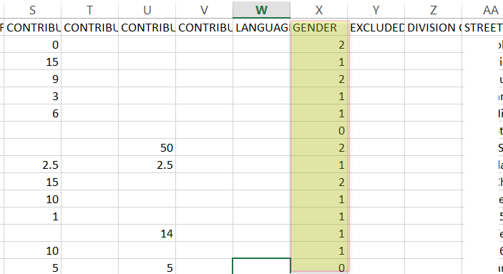

* **Usage of double quotes:** The columns/records in the payroll file should not be double quoted.
* **Usage of commas:** Commas should not be included in any column in the payroll file. Instead, use a single space.

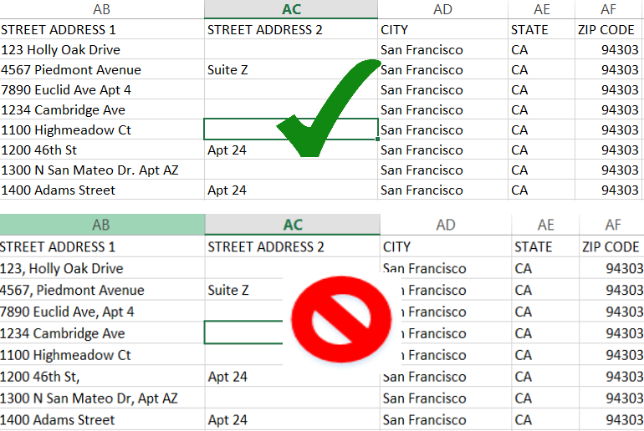

* **Usage of other special characters:** Do not use slashes (/) in numeric data fields (other than date fields), () in any part of a name or as negative values for loan repayments or contributions.
* **Multiple records or multiple lines of information per employee:** Do not have multiple rows for the same participant. If the employee works for more than one department and has a record for each group, combine the information into one record.
* **Format for contributions or field involving amount/percentage values:** The number should only be entered until two decimal places and the number should not be prefixed or suffixed with $ or % symbol. No text character should be included.

**File Format:**

|  |  |  |  |  |  |
| --- | --- | --- | --- | --- | --- |
| **FIELD NAME** | **DATA TYPE** | **MAXIMUM LENGTH** | **DESCRIPTION** | **EXAMPLE** | **Mapping Notes** |
| SSN  *(Social Security Number)* | Numeric | Exactly 9 Numbers | Social Security Number. Include leading zeros. | xxxxxxxxx or xxx-xx- xxxx | Eepssn |
| LAST NAME | Alphanumeric | 30 | Titles (SR, JR, III) follow Last Name; a space should separate Last Name. | DOE SR | Eepnamelast |
| FIRST NAME MI | Alphanumeric | 30 | Space should separate First Name from Middle Initial. It’s optional to use Middle name in the payroll file. | JOHN J | Eepnamefirst space 1st digit of eepnamemiddle |
| DOB  *(Date of Birth)* | Numeric | 10 | Date of Birth  MM/DD/YYYY    Include all leading zeros. | 01/02/1963 | Eepdateofbirth |
| DOH  *(Date of Hire)* | Numeric | 10 | Most Recent Date of Hire  MM/DD/YYYY    Include all leading zeros. | 12/02/1996 | Eepdateoflasthire |
| DOT  *(Date of Termination)* | Numeric | 10 | Date of Termination MM/DD/YYYY    Include all leading zeros. | 08/30/2001 | Eecdateoftermination |
| ANNUAL SALARY | Numeric | 12 | Enter participant’s annual salary. If the participant is paid on an hourly basis, multiply their hourly rate by the estimated number of hours expected to work in a plan year (2,080 hours is the annual number of hours based on a 40 hour work week). | 40000.00 | Eecannsalary |
| HOURS  *Per Payroll)* | Numeric | 12 | If actual hours are not maintained, you may use the equivalency identified in your plan document. | 360 | sum (PehCurHrs) where PehEarnCode does not equal (457P, 457T, CAR  DPIMP, REIMB, GTL, LTD, LTDC, MILES, OTHER, PKDED, SEVER, WLNSA, WLNSB, WLNSC) for Percontrols posted in the date range of the file |
| TOTAL COMP  *Per Payroll)* | Numeric | 12 | Total or gross compensation. | 6000.00 | SUM(PthCurTaxableWages) where PthTaxCode Like ‘%SIT’ |
| ELIGIBLE COMP  *Per Payroll*) | Numeric | 12 | Total employee compensation while employee was eligible to be a participant in the plan (regardless of whether the employee chose to participate). | 6000.00 | sum (PehCurAmt) where PehEarnCode does not equal (457P, 457T, CAR  DPIMP, REIMB, GTL, LTD, LTDC, MILES, OTHER, PKDED, SEVER, WLNSA, WLNSB, WLNSC) for Percontrols posted in the date range of the file |
| NON-REGULAR COMP  *Per payroll)* | Numeric | 12 | Based on plan document. | 500.00 | sum (PehCurAmt) where PehEarnCode does not equal (457P, 457T, CAR  DPIMP, REIMB, GTL, LTD, LTDC, MILES, OTHER, PKDED, SEVER, WLNSA, WLNSB, WLNSC) for Percontrols posted in the date range of the file |
| EMPLOYEE PRE-TAX  CONTRIBUTION  *(Current Payroll Period)* | Numeric | 12 | Pre-tax elective contributions deferred by employees. If applicable, catch-up contributions are combined with employee deferrals and reported as one amount. | 200.00 | Sum(PdhCurAmt) where pdhdedcode = 403BP or 403PC |
| ROTH 401(K) CONTRIBUTION  *(Current Payroll Period)* | Numeric | 12 | After-tax elective contributions deferred by employees. If applicable, catch-up contributions are combined with employee deferrals and reported as one amount. | 60.00 | Sum(PdhCurAmt) where pdhdedcode = 403RC or 403RP |
| OTHER EMPLOYEE  CONTRIBUTIONS  *(Current Payroll Period)* | Numeric | 12 | Voluntary or mandatory after-tax contributions. | 180.00 | Leave blank |
| EMPLOYER MATCH  CONTRIBUTIONS  *(Current Payroll Period)* | Numeric | 12 | Match contributions made by the employer. | 100.00 | Sum(PdhCurAmt) where pdhdedcode = 403BM |
| SAFE HARBOR  CONTRIBUTIONS  *(Current Payroll Period)* | Numeric | 12 | Safe harbor contributions made by employer. | 30.00 | Leave blank |
| OTHER EMPLOYER  CONTRIBUTIONS  *(Current Payroll Period)* | Numeric | 12 | Other contributions such as money purchase, profit sharing, etc. | 75.00 | Leave blank |
| LOAN PAYMENT | Numeric | 12 | If a participant has more than one outstanding loan, combine all payments and report one amount. | 50.00 | Sum(PdhCurAmt) where pdhdedcode = 403L |
| PAYROLL FREQUENCY | Alphanumeric | 12 | W (Weekly), B (Biweekly), S  (Semimonthly), or M (Monthly). | B | pgrPayFrequency |
| CONTRIBUTION RATE PRE-TAX | Numeric | 6 | Enter employee's pre-tax contribution percentage (use whole number without percent sign, 7% = 7). | 10 | If pdhdedcode = 403BP or 403PC send eedbenamt |
| CONTRIBUTION FLAT DOLLAR PRE-TAX | Numeric | 6 | For employees contributing a set dollar amount, enter the pre-tax contribution dollar amount. | 150 | Leave blank |
| CONTRIBUTION RATE ROTH | Numeric | 6 | Enter employee's Roth contribution percentage (use whole number without percent sign, 7% = 7). | 5 | If pdhdedcode = 403RC or 403RP send eedbenamt |
| CONTRIBUTION FLAT DOLLAR ROTH | Numeric | 6 | For employees contributing a set dollar amount, enter the Roth contribution dollar amount. | 125 | Leave blank |
| LANGUAGE | Numeric | 1 | Enter 1 for Spanish-speaking  participants; otherwise, enter 0 or leave blank. | 0 | Leave blank |
| GENDER | Alphanumeric | 6 | M/F or Male/Female | M | Eepgender |
| EXCLUDED EMPLOYEES | Numeric | 1 | Use 1 to label excluded class of employees per your plan document. Use 0 or leave blank if not applicable. | 0 | If Eecpaygroup = HRONLY or eecemptype = STU, SUM, INT or TMP,    or EecDedGroupCode = NONE or NONBE,    or eecemptype = PT and EecScheduledWorkHrs is less than 20 send 1  else leave blank |
| DIVISION CODE | Alphanumeric | 4 | For sorting purposes (different employee divisions or groups). | GRP1 | Leave blank |
| STREET ADDRESS 1 | Alphanumeric | 30 | House number and street.  Should be separated by single space. No commas and quotes allowed. | 123 Main Street | Eepaddressline1 |
| STREET ADDRESS 2 | Alphanumeric | 30 | Apartment number, suite building, PO box, etc. Should be separated by single space. No commas and quotes allowed. | Apt 7 | Eepaddressline2 |
| CITY | Alphanumeric | 18 |  | Portland | Eepaddresscity |
| STATE | Alphanumeric | 2 | Two character state abbreviation. | OR | Eepaddressstate |
| ZIP CODE | Alphanumeric | 5 or 9 | Include leading zeros. | 01234 | Eepaddresszip |
| EMAIL ADDRESS | Alphanumeric | 40 |  | Joe.Smith@Sample. com | eepAddressEMail |
| PAY DATE | Alphanumeric | 10 | Pay date/check date | 01/31/2018 | PrgPayDate |
| PAYROLL BEGIN DATE | Alphanumeric | 10 | Date for the beginning of the pay period for this payroll. | 01/15/2018 | PrgPeriodStartDate |
| PAYROLL END DATE | Alphanumeric | 10 | Date for the end of the pay period for this payroll. | 01/31/2018 | PrgPeriodEndDate |